**React:** A JavaScript library for building user interfaces. It uses JavaScript in the browser to update the page and the user interface without reloading the page.

Using “Just JavaScript” Typically isn’t a great option because

* Writing complex JavaScript code quickly becomes cumbersome
* Complex JavaScript code quickly becomes error-prone
* Complex JavaScript code often is hard to maintain or edit
* React offers a simpler mental mode

When working with React, in the end, you are writing declarative code which means you define the target your user interface states. Not the necessary steps to get there. Instead, React will figure out and perform the necessary steps. On the other hand, when writing JavaScript code, you are writing imperative code, not declarative which means, you are not defining the goal, but instead the steps needed to get there.

You can practice creating a react proyect by typing “react.new” in the search bar without installing anything locally.

**Installing React**

If you want to use install react locally, you will need to install [Node.js](https://nodejs.org/es) because it comes with tools like “vite”. There is an alternative to vite that’s named Create React App. Both of these give you simple commands to create a proyect.

When using vite, you have to write

To check if you have them installed use:

node -v

npm -v

npm create vite@latest react-proyect

Whenever you first install a proyect, you have to run

npm install to download and install all packages

npm run dev to start a development preview server

**Why do you need a special proyect setup to run react?**

React code is JavaScript code that Typically uses JSX (html in JavaScript). This code needs to be transformed and optimized by a build tool like Vite. Then the browser can read this code without JSX.

<script src="assets/scripts/app.js" defer></script> you can use the “defer” option to execute the script only after the rest of the html document has been read and parsed.

It’s also quite common to have a type=”module”. This lets us use the import sintax which allows us to import from script A to script B.

## Javascript refresher

React projects use a build process: the code you write is not he code that gets executed in the browser. Instead, the code is transformed before it’s handed off to he browser. The library that does this is called react-scripts and is located in the package.json

React projects use a build process because:

1. Raw, unprocessed React code won’t execute in the browser because React uses a special JSX feature which is not a default JavaScript feature.
2. The code would not be optimized for production. (e.g., not minifield)

#### Importing

When exporting variables, if you choose to export default “xxx”, you can only have one exporting value.

You can also import everything using import * as util from “./util.js”;

#### Destructuring



***Destructuring in Function Parameter Lists***

For example, if a function accepts a parameter that will **contain an object** it can be destructured to *"pull out"* the object properties and make them available as **locally scoped variables** (i.e., variables only available inside the function body).

Here's an example:

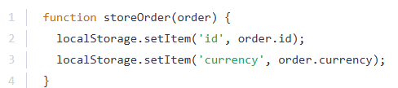

Instead of accessing the order properties via the *"dot notation"* inside the storeOrder function body, you could use destructuring like this:

The destructuring syntax is the same as taught in the previous lecture - just without creating a constant or variable manually.

Instead, id and currency are *"pulled out"* of the incoming object (i.e., the object passed as an argument to storeOrder).

It's very important to understand, that storeOrder **still only takes one parameter** in this example! It does **not** accept two parameters. Instead, it's one single parameter - an **object** which then just is destructured internally.

The function would still be called like this:

1. storeOrder({id: 5, currency: 'USD', amount: 15.99}); // one argument / value!

**Destructuring allows you to easily access the values of arrays or objects and assign them to variables.**

Here's an example for an array:

And here for an object:

Destructuring is very useful when working with function arguments. Consider this example:

Here, we only want to print the name in the function but we pass a complete person object to the function. Of course this is no issue but it forces us to call personObj.name inside of our function. We can condense this code with destructuring:

We get the same result as above but we save some code. By destructuring, we simply pull out the name  property and store it in a variable/ argument named name  which we then can use in the function body.

#### The spread operator

If we want to merge the hobbies list with another newHobbies list, I could use the special spread operator which is the three dots and then the name of the first array. These three dots will pull all the elements of the array and add them as separate values to this new list.

#### ES6 Arrow Functions

Read more: [Arrow function expressions - JavaScript | MDN](https://developer.mozilla.org/en-US/docs/Web/JavaScript/Reference/Functions/Arrow_functions)

Arrow functions are a different way of creating functions in JavaScript. Besides a shorter syntax, they offer advantages when it comes to keeping the scope of the this  keyword (see [here](https://developer.mozilla.org/en-US/docs/Web/JavaScript/Reference/Functions/Arrow_functions#No_binding_of_this)).

Arrow function syntax may look strange but it's actually simple.

which you could also write as:

becomes:

**Important:**

When having **no arguments**, you have to use empty parentheses in the function declaration:

When having**exactly one argument**, you may omit the parentheses:

When **just returning a value**, you can use the following shortcut:



That's equal to:

#### Methods of arrays

The following page gives a good overview over the various methods you can use on the array prototype - feel free to click through them and refresh your knowledge as required: <https://developer.mozilla.org/en-US/docs/Web/JavaScript/Reference/Global_Objects/Array>

Particularly important in this course are:

* map()  => <https://developer.mozilla.org/en-US/docs/Web/JavaScript/Reference/Global_Objects/Array/map>
* find()  => <https://developer.mozilla.org/en-US/docs/Web/JavaScript/Reference/Global_Objects/Array/find>
* findIndex()  => <https://developer.mozilla.org/en-US/docs/Web/JavaScript/Reference/Global_Objects/Array/findIndex>
* filter()  => <https://developer.mozilla.org/en-US/docs/Web/JavaScript/Reference/Global_Objects/Array/filter>
* reduce()  => <https://developer.mozilla.org/en-US/docs/Web/JavaScript/Reference/Global_Objects/Array/Reduce?v=b>
* concat()  => <https://developer.mozilla.org/en-US/docs/Web/JavaScript/Reference/Global_Objects/Array/concat?v=b>
* slice()  => <https://developer.mozilla.org/en-US/docs/Web/JavaScript/Reference/Global_Objects/Array/slice>
* splice()  => <https://developer.mozilla.org/en-US/docs/Web/JavaScript/Reference/Global_Objects/Array/splice>

## React Essentials

#### Components

Components are reusable building blocks which you can create and which you then combine to build the overall user interface. **React apps are built by combining components.**

Why components?

* Reusable building blocks: create small building blocks and compose the UI from them.
* Related code lives together: Related HTML, JS and CSS code is stored together.
* Separation of concerns: different components handle different data & logic. It vastly simplifies the process of working on complex apps.

#### Setting up the starting project

First you have to have node js. You can use this commands in cmd to check if you have them installed

node -v & npm -v

Then you have to use npm install before running the project.

Then you use

npm run dev

to start the development server. This development server will allow you to visit a preview of the website.

The files have the extension .jsx because it is a JavaScript file that uses non-standard JavaScript syntax. It uses a JavaScript syntax extension called JSX which stands for JavaScript Syntax eXtension. This extension allows developers to describe and create HTML elements by writing HTML markup code inside of JavaScript files. But it is a feature that’s not supported by browsers. Instead, the code is transformed by the development server before it reaches the browser.

#### Rules of components

* Name should start with uppercase character
* Returns “Renderable” content

Look how I write the header in a function and utilize it in the html.

#### Loading images

Using src/… is not the best way to add images because it is pointing to an image in the src folder and the image might get lost once we prepare this react project for deployment.

So, to load images, you have to use an import statement

#### Props

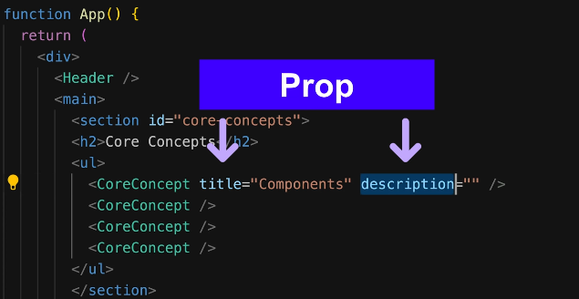React allows you to pass data to components via a concept called **Props**.

In normal JavaScript functions, you would simply add one or more parameters to accept input values and then use those input values. But when working with React component functions you can only accept one parameter which typically is named props. Since it’s react who will execute this function, its him who will pass a value for this props parameter to the function when it calls it. And the value that will be passed for this parameter to the function by react will be an object that has all the key value pairs that were assigned here.

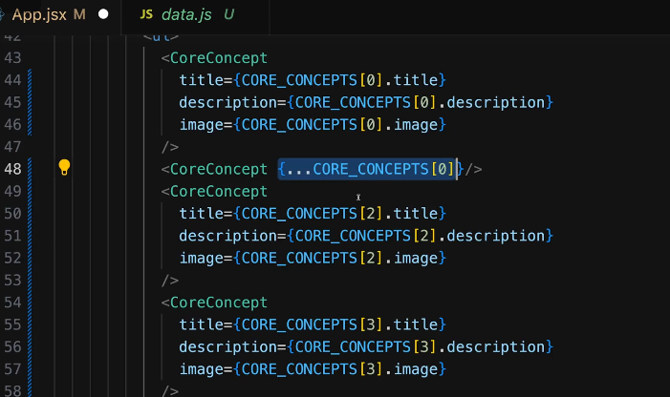If your prop names are similar to the properties of the object that you are using, you can use the spread operator to pull out all the key value pairs of an object

You can also use object destructuring by adding opening and closing curly braces as an input parameter

## Buttons

There is one prop which you will always get, the special, built-in children prop. This prop refers to the content between you component text.

Este funciona como valor de salida

There is a concept called **state** which is to register variables that are handled by react and that are updated with the help of a function that’s provided by react that will also tell react that data changed.

State function must be imported from the React library

All the functions that start with **use** are called *React hooks.*

Also, you must call those hook functions directly inside of the component function. Not nested inside of a component function.

## Classes

If you want to add something like a class to a button, you need to use

className = “”

### Outputting list data dynamically

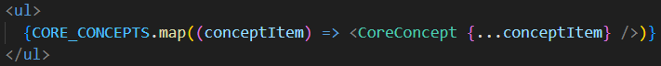

You can transform arrays in JavaScript with the help of the built-in map method. Which produces a new array based on the existing array. For that, map takes a JavaScript function like an arrow function and that function will receive an array item as an input. This arrow function will now be executed by JavaScript for every item in that array. Inside of that arrow function we want to transform this item to the core concept component being used as JSX Also remember that when dynamically outputting a list of elements, every element should receive a unique "key" to help React tell the list items apart.

## Introduction to fragments

There is a common error that is: JSX expressions must have one parent element. This problem is that in the return statement you are returning more than one sibling elements. You cannot do that. You have to return one parent element with n number of children. This is because **in JavaScript you cannot return two values by just wrapping them with parentheses and just splitting them in two lines.**

For this, React gives you an alternative: an special fragment component which you can use as a wrapper but you don’t want to render an actual element such as a div. You have to import **Fragment** from react and replace the outer div with Fragment. **Or** you can simply use <> … </> without importing fragments.

## When should you split components?

Having a single component that deals with a lot of different thing typically is a sign that you might want to split it up and break it up into multiple smaller sub Components.

If you are managing useState, whenever that state is updated using the set… function, **the entire component function to which this state belongs to is re-executed** so that react is able to find out if something changed in the jsx code and is able to update the screen. **Also, if there are other components imported in there, those will also re-execute.**

Being able to identify good places for extra Components and being able to split up your big components into smaller components and to separate responsibilities is an important skill for every react developer.

Usually you want to separate the component by features

### Props are not forwarded automatically

When you are setting attributes on a custom component, those props are not automatically forwarded to the JSX code used inside of that component.

To solve this, we can use a pattern called **forwarded props** or **proxy props**

When de-structuring the props of an export default function using parentheses and corchetes, we can also add some special built-in JavaScript syntax where we add three dots and then, any identifier of our choice (in this case we called it props but it can be whatever name).

These three dots tells JavaScript to collect all other props that might be received on this section component and merge them into a props object.

This will now ensure that all extra props that might be set on our custom section component will be forwarded to this built-in section element.